Drawing ROC Curves

Test Hidden Nodes Number (Learning Rate: 0.01; Iteration Times: 10)
Hidden Nodes Number: 20
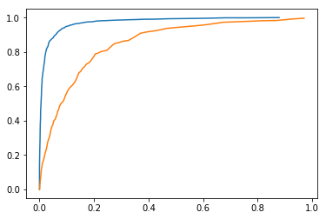
Hidden Nodes Number: 30
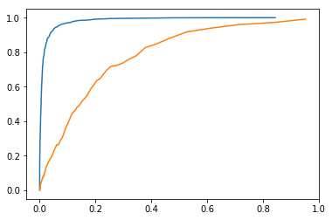
Hidden Nodes Number: 40
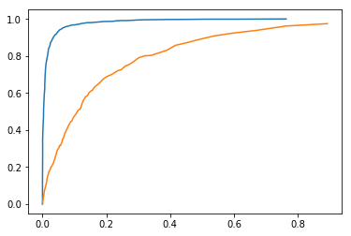

Test Learning Rate (Hidden Nodes Number: 20; Iteration Times: 10)
Learning Rate: 0.01
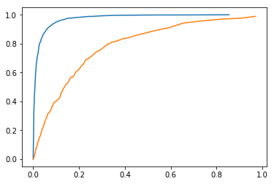
Learning Rate: 0.1
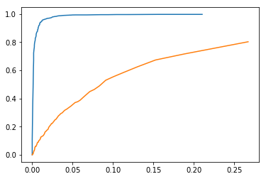
Learning Rate: 0.2
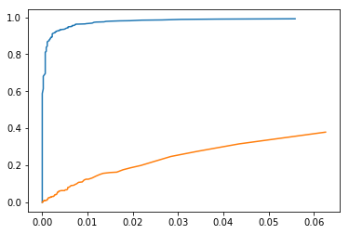

Test Iteration Times (Hidden Nodes Number: 20; Learning Rate: 0.01)
Iteration Times: 10
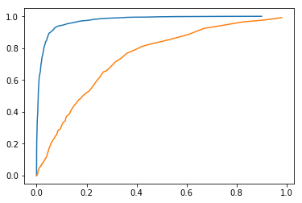
Iteration Times: 20
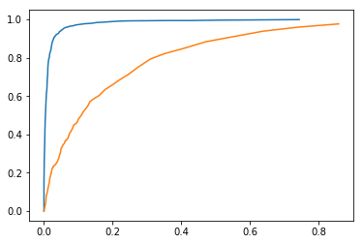
Iteration Times: 30
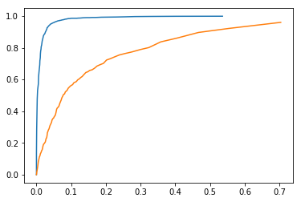

Blue Line: Training Orange Line: Testing

